Q4 Stored Proc

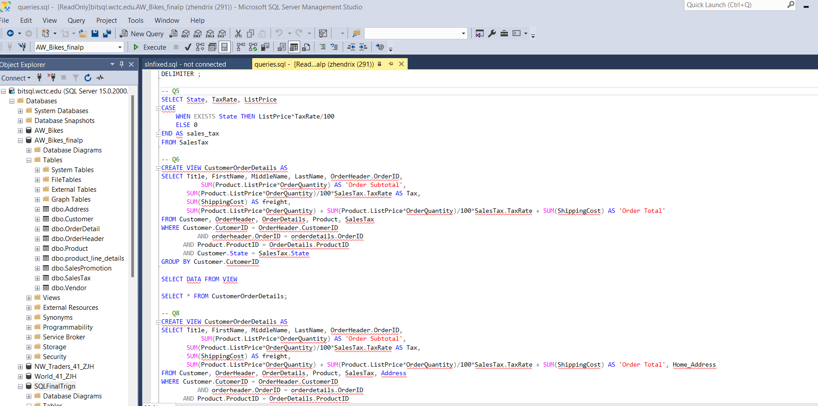

As you can see I am connected to the correct Database and everything just confused